6.Restricting and sorting data

1. Create a query to display the last name and salary of employees earning more than 12000.

ANS: select * from employees where salary>12000;

2. Create a query to display the employee last name and department number for employee number 176.

ANS: select lastname, department_id from employees where employee_id=176;

3. Create a query to display the last name and salary of employees whose salary is not in the range of 5000 and 12000. (hints: not between )

ANS: select lastname, department_id from employees where salary not between 5000 and 12000;



4. Display the employee last name, job ID, and start date of employees hired between February 20,1998 and May 1,1998.order the query in ascending order by start date.(hints: between).

ANS: SELECT LASTNAME,JOB_ID,HIREDATE FROM EMPLOYEES WHERE HIREDATE BETWEEN TO_DATE('20-2-1998','DD-MM-YYYY') AND TO_DATE('1-5-1998','DD-MM-YYYY')

ORDER BY HIREDATE ASC;



5. Display the last name and department number of all employees in departments 20 and 50 in alphabetical order by name.(hints: in, orderby).

ANS: SELECT LASTNAME, DEPARTMENT_ID FROM EMPLOYEES WHERE DEPARTMENT_ID IN(20,50) ORDER BY FIRSTNAME;



6. Display the last name and salary of all employees who earn between 5000 and 12000 and are in departments 20 and 50 in alphabetical order by name. Label the columns EMPLOYEE, MONTHLY SALARY respectively.(hints: between, in).

ANS: SELECT LASTNAME AS EMPLOYEE, SALARY AS MONTHLY_SALARY FROM EMPLOYEES WHERE SALARY BETWEEN 5000 AND 12000

AND DEPARTMENT_ID IN(20,50)

ORDER BY FIRSTNAME;



7. Display the last name and hire date of every employee who was hired in 1994.(hints: like).

ANS: SELECT LASTNAME, HIREDATE FROM EMPLOYEES WHERE HIREDATE LIKE '%1994';



8. Display the last name and job title of all employees who do not have a manager.(hints: is null).

ANS: SELECT LASTNAME , JOB_ID FROM EMPLOYEES WHERE MANAGER_ID IS NULL;



9. Display the last name, salary, and commission for all employees who earn commissions. Sort data in descending order of salary and commissions.(hints: is not nul,orderby).

ANS: SELECT LASTNAME,SALARY ,COMMISSION_PCT FROM EMPLOYEES

WHERE COMMISSION_PCT IS NOT NULL

ORDER BY SALARY DESC, COMMISSION_PCT DESC;

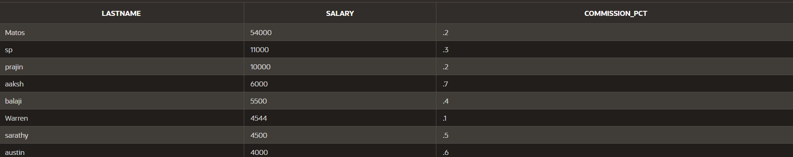

10. Display the last name of all employees where the third letter of the name is a.(hints:like).

ANS: SELECT * FROM EMPLOYEES WHERE LASTNAME LIKE '__a%';



11. Display the last name of all employees who have an a and an e in their last name.(hints: like)

ANS: SELECT LASTNAME FROM EMPLOYEES

WHERE LASTNAME LIKE '%a%'

AND LASTNAME LIKE '%e%';



12. Display the last name and job and salary for all employees whose job is sales representative or stock clerk and whose salary is not equal to 2500 ,3500 or 7000.(hints:in,not in)

ANS: SELECT LASTNAME,JOB_ID,SALARY FROM EMPLOYEES WHERE

JOB IN ('sales representative', 'stock clerk')

SALARY NOT IN (2500,3500,7000);

